Kaggle Notebook using Python for Time series analysis  
<https://www.kaggle.com/code/prashant111/complete-guide-on-time-series-analysis-in-python>

**Why do we choose residuals which are random compared to residuals which show pattern?**

Residuals are what are left over after you fit your model and compare it to what you started with.

If the residuals are not randomly distributed, that means they contain additional structure which was missed by your model.

A good model matches the underlying process it is attempting to capture.

General theory on time series analysis (A book on forecasting principles and practice)

Only Text: <https://otexts.com/fpp2/stl.html>

This is with videos: <https://otexts.com/fpp3/>

Forecast project workflow:

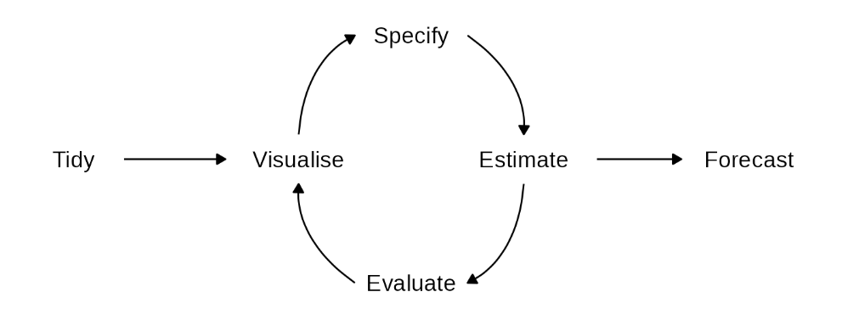

Naïve forecasting method

<https://www.youtube.com/watch?v=EggOdnSsolU>

This video talks about model selection.

Then discussed about the Naïve forecast method.

AIC metric for evaluation of model

<https://timeseriesreasoning.com/contents/akaike-information-criterion/>

BIC

<https://en.wikipedia.org/wiki/Bayesian_information_criterion>

Maximum likelihood estimator

<https://online.stat.psu.edu/stat415/lesson/1/1.2>

A nice derivation of normal distributions mean: <https://www.statlect.com/fundamentals-of-statistics/normal-distribution-maximum-likelihood>

ACF (Fantastic explanation)

<https://otexts.com/fpp3/acf.html>

More details of how to use PACF plot and ACF plot to determine ARIMA parameters

<https://people.duke.edu/~rnau/Slides_on_ARIMA_models--Robert_Nau.pdf>

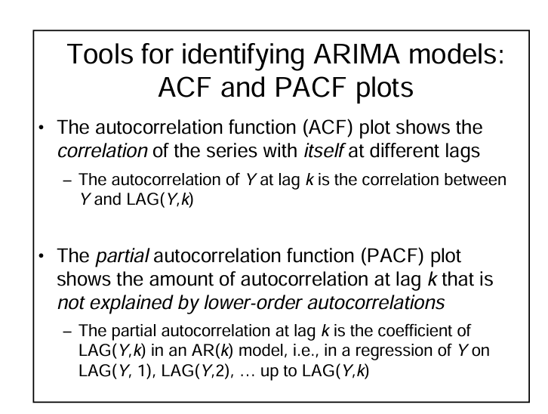

The PACF is the coefficient of y(t-i) in a AR(k) model.

i.e

AR(k) => y(t) = c + a1.y(t-1) + a2.y(t-2) + ……. + ak.y(t-k)

<https://people.duke.edu/~rnau/411arim3.htm#signatures>

This article gives you two rules to identify the AR and MA terms